**Section 2: Childhood and Family Life of Prince Siddhartha**

In the previous section of this series, we delved into the remarkable birth of Prince Siddhartha and the extraordinary events surrounding his arrival into this world. Now, we explore his early years, from childhood to the transformative moment at the age of twenty-nine, when he left his royal life behind to embark on the path of an ascetic in search of liberation.

**The Family of Prince Siddhartha**

Prince Siddhartha’s name, Siddhartha, means “**he who achieves his goal,**”  **[1]** and indeed, his life would unfold to achieve the supreme goal of enlightenment, bringing profound peace and wisdom to countless beings. Born in the city of Kapilavattu, Prince Siddhartha belonged to the Sakya Clan, a noble family of rulers. His father, King Suddhodana, and his mother, Queen Mahamaya, were revered for their wisdom and compassion. [2] However, the life of this noble prince was marked by profound sorrow, as his mother, Queen Mahamaya, passed away just seven days after his birth. [3]

In a gesture of love and compassion, Queen Prajapati, Queen Mahamaya’s sister and King Suddhodana’s second consort, stepped forward as the prince’s foster mother. Queen Prajapati would later become a prominent figure in the Buddha’s teachings, being the first to be ordained as a Bhikkhuni in the community of nuns, embodying the noble qualities of devotion and compassion.

Prince Siddhartha also had a half-brother, Prince Nanda, and a half-sister, Princess Nandā, children of King Suddhodana and Queen Prajapati, who were also part of the royal family that would witness the unfolding of his extraordinary destiny.

The scriptures beautifully recount the significance of Prince Siddhartha’s family. In the Mahāpadāna Sutta (DN:14), the Devas express the auspiciousness of the Buddha’s birth and his noble lineage:

*“…In this fortunate aeon now, the Lord Buddha has arisen in the world… His father is King Suddhodana, his mother was Queen Maya, and his royal capital is Kapilavattu…”*

In the Udana, Venerable Ānanda Thera reflects on the profound nature of the Buddha’s mother’s passing: [4]

*“…It’s incredible, sir, it’s amazing! How short-lived was the Blessed One’s mother! For seven days after the Blessed One was born, his mother passed away and was reborn in the host of joyful gods (Tusita heaven)”*

The Buddha, in his compassionate wisdom, explains:

*“That’s so true, Ānanda! For the mothers of being’s intent on awakening are short-lived. Seven days after the being’s intent on awakening are born, their mothers pass away and are reborn in the host of joyful gods…”*

This passage illuminates the deep connection between the Buddha’s life and the unfolding of his path to enlightenment, revealing the divine significance of his birth and the transcendent nature of his family. The early loss of his mother, though heartbreaking, set the stage for Siddhartha’s eventual awakening and the subsequent teachings that would uplift all beings.

The noble birth of Prince Siddhartha in the Sakyan family was not just a royal event; it was the beginning of a journey that would transcend worldly existence, ultimately bringing forth the wisdom that would guide countless beings to liberation. The compassion and the divine purpose behind his birth and his family’s role in his life serve as a profound reminder of the interconnectedness of all beings and the deep compassion that the Buddha embodied, not only for his family but for the entire world.

**Ven. Kāludāyi Thera**, a devoted disciple of the Buddha, expressed the following: [5]

*“…* ***Suddhodana*** *is the name of the Great Seer’s father, and* ***Māyā*** *is the name of the Buddha’s mother, who, having nurtured the Bodhisatta in her womb, now rejoices in the threefold divine realm after the dissolution of her body. She,* ***Gotamī****, having passed away, has transcended this world and is now blessed with heavenly sensual pleasures…”*

In the Dakkhiṇāvibhanga Sutta (MN:142), Venerable Ānanda also affirms that Queen Mahāpajāpatī was the Buddha’s foster mother. He states:

*“… Mahāpajāpatī Gotamī has been of great assistance to the Blessed One, venerable sir. As his mother’s sister, she became his nurse and foster mother, the one who gave him milk. She suckled the Blessed One after his own mother passed away…”*

Queen Prajāpati, reflecting on her unique role as the Buddha’s foster mother, said: [6]

*“…* ***Sublime One****, I am your foster mother, yet you nourished me with the milk of the* ***True Dhamma****. Therefore, you are my father…* ***Greatest Hero****, I raised you by nursing you, and you supported me in building this* ***Dhamma body****. I quenched your thirst with my breast milk, and the* ***Dhamma milk*** *you provided extinguished my worldly desires. While titles like ‘King’s mother’ and ‘King’s wife’ hold great significance, the title of ‘Buddha’s mother’ surpasses them all…”[7]*

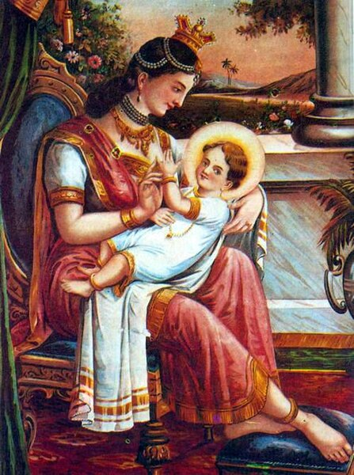

**Prince Siddhartha (Gotama Buddha) with Maha Pajapati Gotami—Foster mother**

**Picture Courtesy:** https://commons.wikimedia.org/wiki/File:

**Prince Siddhartha’s Childhood**

Prince Siddhartha grew up in the comfort of royalty, sheltered from the outside world. However, even in his early years, two significant and unusual spiritual events occurred, foreshadowing the path he would one day follow, as documented in the scriptures.

**Prophesy about Buddhahood**

The first event took place when the renowned ascetic, Asita (also known as Kāladevala), visited King Suddhodana to see the newborn prince. The ascetic, upon observing the child, prophesied that the baby would one day become a great spiritual leader: [8]

*“…He is supreme, the best of men! This boy shall reach the highest awakening. With perfectly purified vision, compassionate for the welfare of many, he will roll forth the wheel of the teaching. His spiritual path will spread far and wide…”* [9]

This prophecy marked the beginning of the divine significance of Prince Siddhartha’s life, setting the stage for his future as the Buddha.

**The prophecy of the seer Asita** : Source- Pakistan, Gandhara region, 3rd/4th century; slate Museum Rietberg, Zurich; Inv. No. RVI 11 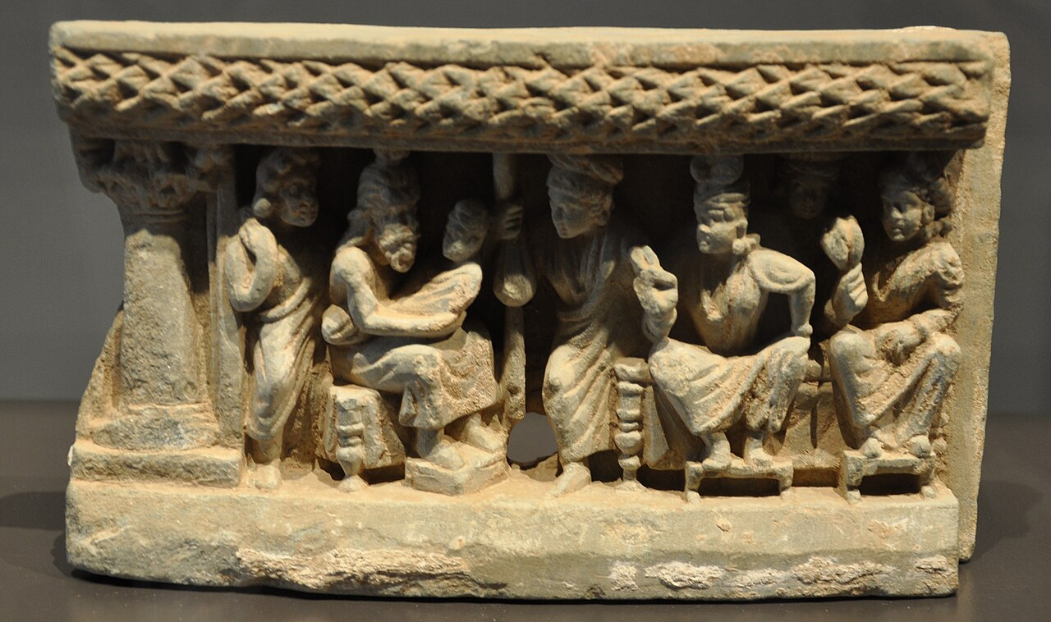(public domain). Picture courtesy: https://en.wikipedia.org/wiki/Asita

**Meditative Attainment as a Child**

The second significant event took place during a ploughing festival organized by his father. At just seven years old, Prince Siddhartha was found meditating under a Rose Apple tree. In this serene moment, it is said that he entered the first Jhana, a deep state of meditation. This early experience of profound samadhi and mindfulness would later lay the foundation for his spiritual journey to enlightenment.

After attaining Buddhahood, the Blessed One recalled this moment from his childhood, describing it in the following way:

*“…I recall that when my father, the Sakyan, was occupied, I sat in the cool shade of a rose-apple tree, completely secluded from sensual pleasures and free from unwholesome states. In this peaceful solitude, I entered and abided in the first jhāna, accompanied by applied and sustained thought, with rapture and pleasure born of seclusion…”*[10]

This early meditation marked the beginning of Prince Siddhartha’s connection with the path of inner peace, which would ultimately lead him to the realization of enlightenment.

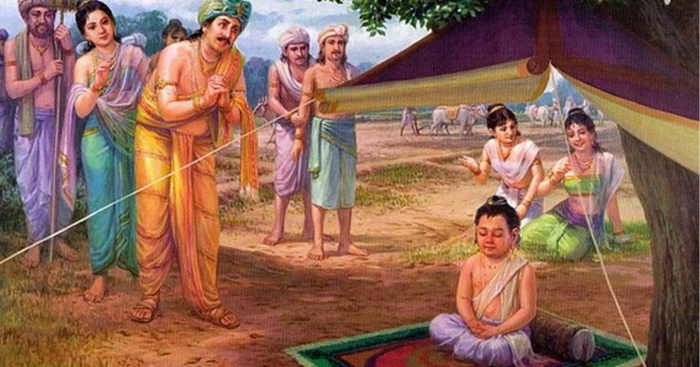

**Prince Siddhartha’s First Meditation.** Picture courtesy: https://sumagaasapuwa.com/wap-magul-uthsawaya/

**Young Prince Siddhartha**

According to the scriptures, prince Siddhartha lived in the royal palace inKapilavattu, the capital of the Sakyan Clan until the age of twenty-nine. The Buddha recalls:

*“I lived in lay life for twenty-nine years… Bhadda Kacchana (Yashodhara) was my queen… Rahula was my son’ .* [11]

In this sutta the Buddha describes his princely life:

*“…I was delicately nurtured…at my father’s residence lotus ponds were made just for my enjoyment: in one of them blue lotuses bloomed, in another red lotuses, and in a third white lotuses… I used no sandalwood unless it came from Kāsi and my headdress, jacket, lower garment, and upper garment were made of cloth from Kāsi … I had three mansions: one for the winter, one for the summer, and one for the rainy season… I spent the four months of the rains in the rainy-season mansion, being entertained by musicians, none of whom were male and I did not leave the mansion…”*[12]

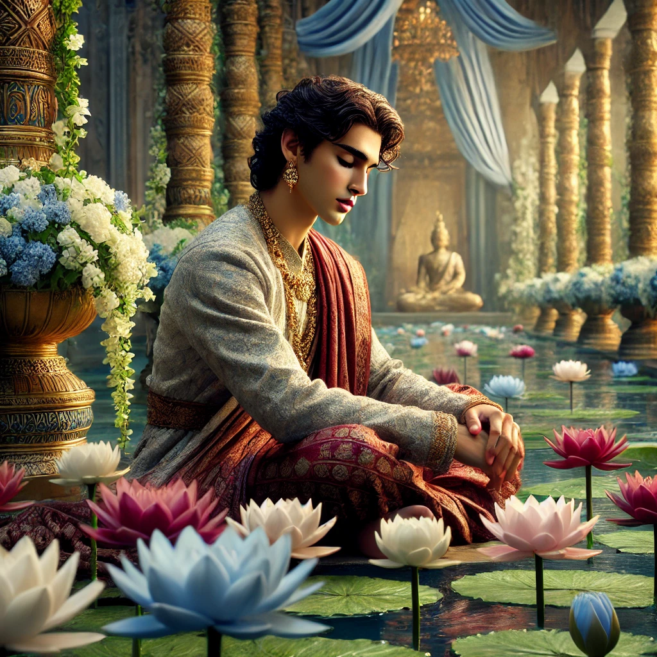**Young Prince Siddhartha in the royal palace** (may be reflecting of uncertainty of sensual life) Image specially created by ChatGPT.

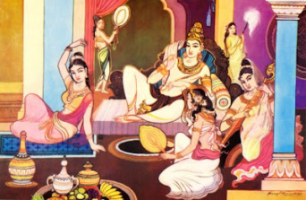**Royal life of Prince Siddhartha**

Source: The Buddha and Buddhism https://explorebuddhism.weebly.com/royal-life.htm

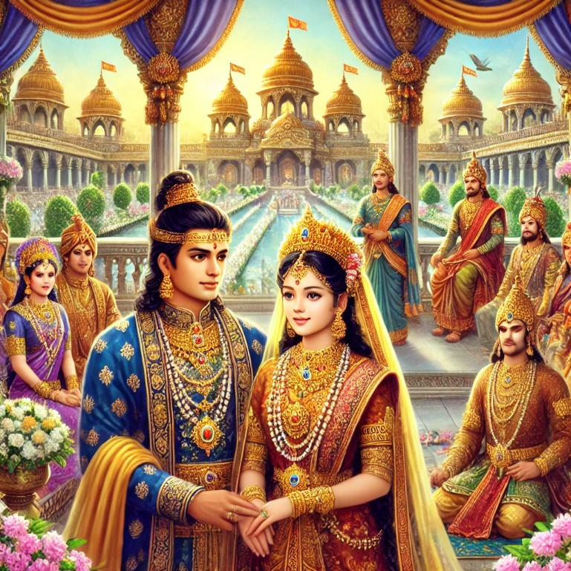

**Royal wedding of Prince Siddhartha and princess Yasodhara**

Image specially created by ChatGPT.

Additionally, this section includes a description of the Buddha’s close family members. It is fitting to highlight how, after attaining enlightenment, the Buddha guided his parents and relatives on the spiritual path. Below, we provide a profile of each family member and their journey into spiritual life.

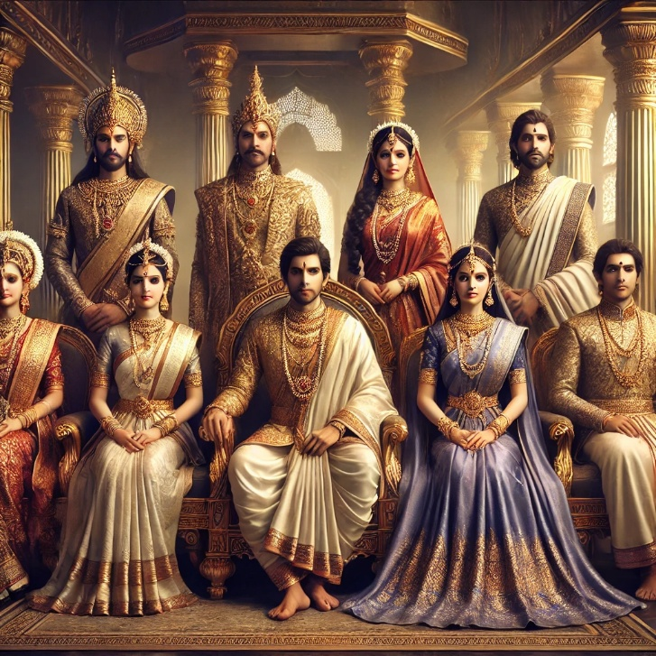

**Royal Family of Kapilavattu** Seated:Prince Siddhartha and princess Yasodhara in the center, left: Amita Devi (Yasodhara’s mother) Princess Nandā, right Prince Nanda Standing: center King Suddhodana and Queen Prajapathi, left King Suppabuddha and right Prince Devadatta (Yasodhara’s father and brother) Image specially created by ChatGPT.

**Princess Yasodharā: The Devoted Companion Across Lifetimes**

According to tradition, Princess Yasodharā (Bhaddā Kaccānā) was not only the beloved wife of Prince Siddhartha in this life but also his devoted companion across countless past existences. Their bond was one of unwavering faithfulness and spiritual dedication. At the age of sixteen, she married Prince Siddhartha, sharing a life of royal splendour until he renounced the world in search of ultimate truth. [13]

Born into the noble Koliya clan of Devadaha, she was the daughter of King Suppabuddha and Queen Amita Devi, who was the sister of King Suddhodana. Together, Yasodharā and Siddhartha had a son, Rāhula.

Despite the deep sorrow of his departure, Princess Yasodharā remained steadfast in her devotion, choosing a path of reflection and inner growth. Later, she embraced the monastic life as a bhikkhunī and attained full Enlightenment. Recognizing her extraordinary spiritual accomplishments, the Buddha declared her the foremost among bhikkhunīs in “great direct knowledge.” [14]

When Yasodharā Theri was seventy-eight years old, before her Parinibbāna —her final passing, she paid her respect to the Blessed One:

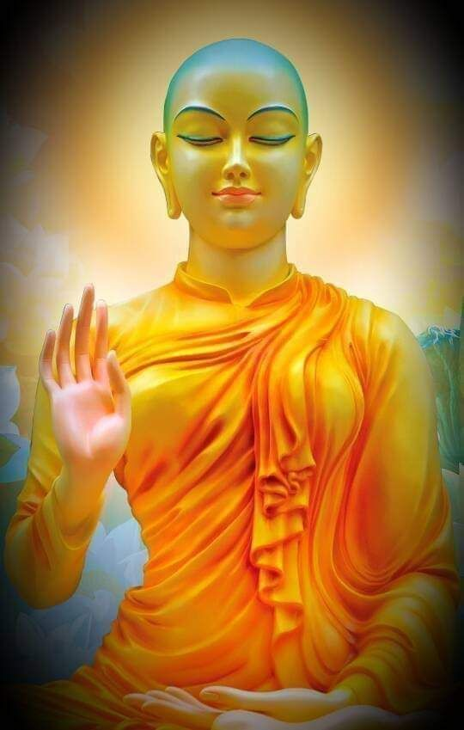*“…Iam Yasodharā, Hero; in the home I was your chief queen, born in the clan of the Śākyas, established among the women in your household, O Hero, I was the leader, the lord of all of the women there … “I am Yasodharā, Hero; I worship your feet, Eyeful One…”* [15].

**Arahant Bhikkhuni Yasodharā** : Picture courtesy: Pinterest

https://in.pinterest.com/pin

**Below: Prince Nanda following the Blessed One-** though he was carrying the bowl of the Buddha his mind was on his wife to be ‘Janapada Kalyani’ who was asking him to come back soon. Image: specially created by Chat:GPT.

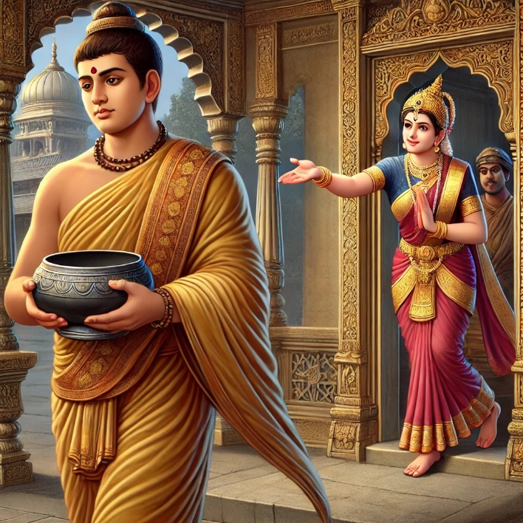

**Prince Nanda**

Prince Nanda, also known as Nanda Gotama, was the Buddha’s half-brother, born to King Suddhodana and Queen Mahāpajāpatī Gotamī.

On one occasion, the Blessed One, accepting an invitation from his father, visited Kapilavatthu. At that time, Prince Nanda was preparing to marry a beautiful Sakyan maiden known as *Janapada Kalyāṇī*—meaning “the most beautiful maiden of the province.” After taking his meal at the palace, the Buddha handed his alms bowl to Prince Nanda and silently walked with him to the monastery. Out of deep respect for the Blessed One, Nanda agreed to ordain as a monk when asked, though his mind remained attached to the comforts of royal life and his beloved bride-to-be.

Longing to return to his former life, Nanda struggled with monastic discipline. Sensing his inner conflict, the Buddha, using his spiritualpowers, transported Nanda to the *Tāvatiṁsa* Deva realm, where celestial maidens of surpassing beauty resided. Pointing to them, the Buddha said: [16]

*“…Rejoice, Nanda, rejoice! I guarantee you five hundred dove-footed nymphs.”*

Overcome by desire, Nanda responded:

*“If, sir, you guarantee me five hundred dove-footed nymphs, I shall happily lead the spiritual life under the Buddha.”*

When his fellow monks discovered that Nanda was practicing merely for the reward of heavenly pleasures, they ridiculed him. Humiliated and ashamed, Nanda resolved to dedicate himself wholeheartedly to the path. Through diligent practice—living in seclusion, striving with unwavering determination—he soon realized the highest goal. In this very life, he attained Arahantship, becoming one of the *perfected ones.*

The Buddha later declared that among the Bhikkhu Saṅgha, Nanda was foremost in guarding the doors of the sense faculties. [17]

In the Theragatha, the noble Nanda Thera recorded as having said:

*“…focusing on the wrong things,*

*I was addicted to ornamentation.*

*I was vain with a desire for pleasures of the senses.*

*With the help of the Buddha,*

*the kinsman of the Sun, so skilled in means,*

*I practiced rationally and extracted attachment*

*to continued existence from my mind…”* [18]

Nanda Thero mentioned that in one of his former births he met the Buddha Padumuttara and this is what that previous Buddha said about his future life:

*“…after spending heavenly and human pleasures, due to good kamma, you will be born as a younger brother of Buddha Gotama… attached to sensual pleasures you will be guided by the Blessed One, …will be peaceful and attain to Arahathood”* [19]

**Princess Nandā Gotamī**

Like Prince Nanda, Princess Nandā was the child of King Suddhodana and Queen Mahāpajāpatī Gotamī, making her the Buddha’s half-sister. Renowned for her exceptional beauty, she was called *Sundarī Nandā*—"Beautiful Nandā."

When her mother, Queen Mahāpajāpatī, renounced lay life to become the first bhikkhunī, Princess Nandā followed her out of respect. However, in the early days of her monastic life, she remained preoccupied with her own beauty, neglecting her Dhamma practice.

Recognizing her attachment, the Buddha compassionately guided her by revealing the fleeting nature of physical beauty. Upon realizing this profound truth, Nandā Theri awakened to the deeper reality of existence and attained full enlightenment.

The Blessed One later declared her the foremost among bhikkhunīs in meditation. [20]

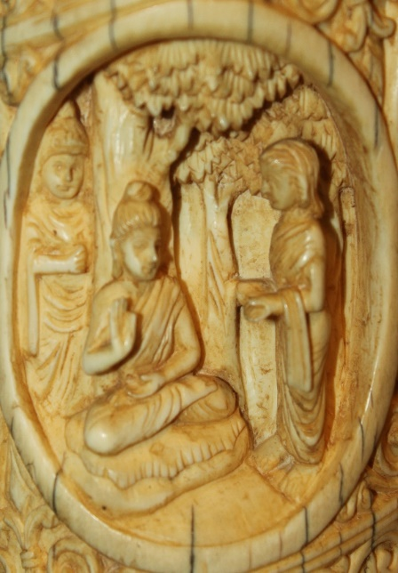**The Buddha advising Nandā Theri**. Picture courtesy: Wikipedia https://en.wikipedia.org/wiki/Sundari_Nanda

In Therigatha of Venerable Nandā stated how the Buddha regularly advised her with these verses:

*“…Nandā, see this bag of bones as diseased, filthy, and rotten. With mind unified and serene, meditate on the ugly aspects of the body. Meditate on the sign-less, give up the underlying tendency to conceit; and when you comprehend conceit, you will live at peace…”.* [21]

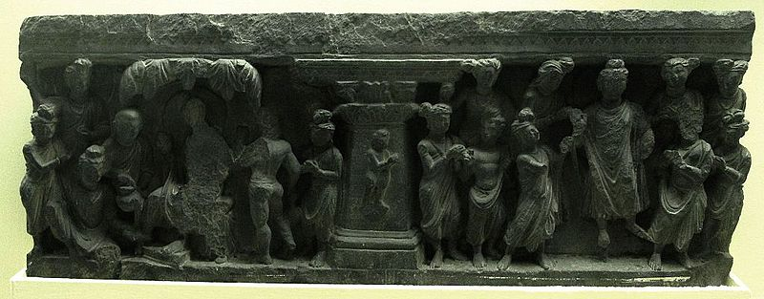**Ordination of Rahula**: source: Photograph from the [Indian Museum](https://en.wikipedia.org/wiki/Indian_Museum) in [West Bengal](https://en.wikipedia.org/wiki/West_Bengal) taken by [Anandajoti](https://commons.wikimedia.org/wiki/User:Anandajoti). Picture Courtesy: https://commons.wikimedia.org/wiki/User:Anandajoti

**Prince Rāhula: The Young Renunciant**

Prince Rāhula, the only son of Prince Siddhartha and Princess Yasodharā, was known as *Rāhula Bhadda*— “fortunate Rāhula”—for he was blessed to be the son of the Blessed One. Yet, his true fortune lay not in royal privilege, but in the rare opportunity to walk the noble path under the direct guidance of the Buddha himself.

According to tradition, when Prince Siddhartha renounced the world, Rāhula was still an infant. He was raised in the comforts of the palace by his loving mother and grandparents, unaware that his destiny would soon lead him far beyond the luxuries of royal life.

The *Vinaya Pitaka* describes the remarkable event of his ordination at the tender age of seven: [22]

After spending time in Rājagaha, the Buddha set out on a journey back to Kapilavattu. Upon his arrival, he stayed at the Banyan Tree Monastery. The next morning, he robed up and went to the palace of King Suddhodana, where a seat had been prepared for him.

Seeing the Buddha, Queen Yasodharā gently encouraged her young son:

*“This is your father, Rāhula. Go and ask for your inheritance.”*

With innocent reverence, Prince Rāhula approached the Buddha, stood before him, and softly said:

*“Ascetic, your shadow is pleasant.”*

As the Buddha rose to leave, the child followed him, joyfully calling out:

*“Give me my inheritance! Give me my inheritance!”*

Then the Buddha turned to Venerable Sāriputta and said:

*“Well then, Sāriputta, give Rāhula the going forth.”*

Thus, at just seven years old, Prince Rāhula renounced his princely life and entered the monastic order as a novice monk. Venerable Sāriputta was entrusted with his training, guiding him with wisdom and compassion.

**King Suddhodana’s Grief**

However, the news of Rāhula’s ordination pierced King Suddhodana’s heart with sorrow. Already having endured the departure of both Siddhartha and Nanda, the loss of his beloved grandson was too much to bear. He went to the Buddha and, with a heavy heart, expressed his pain:

*“When the Buddha went forth, it was painful for me. When Nanda went forth, it was painful again. But with Rāhula, it is even worse. A parent’s love cuts deep—it cuts through the outer and inner skin, through the flesh, sinews, and bones, reaching all the way to the marrow. Please, Blessed One, do not grant ordination to a child without the parents’ permission.”*

Respecting his father’s plea, the Buddha established a new rule: henceforth, no child would be ordained without the consent of their parents.[23]

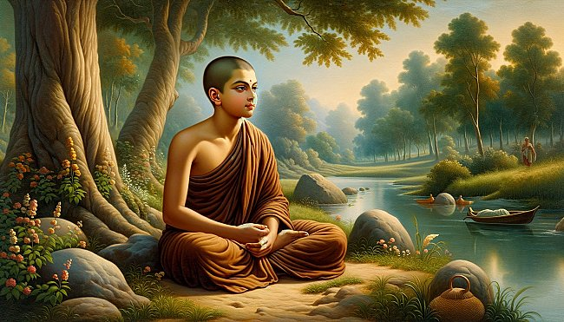Though Rāhula had once sought an inheritance of wealth and power, under the Buddha’s guidance, he would come to receive the greatest inheritance of all—the wealth of the Dhamma, the path to ultimate liberation.

**An artist’s depiction of young monk Rāhula**

Picture courtesy:

<https://www.originalbuddhas.com/blog>

A few years after his higher ordination, at age twenty-one, Rāhula Thera became an Arahant. The special event is described in the scriptures:

*“ …then, while the Blessed One was alone in meditation, a thought arose in his mind thus: “The states that ripen in deliverance have ripened in Rāhula. Suppose I was to lead him on further to the destruction of the taints… now on that occasion many thousands of deities followed the Blessed One, thinking: “Today the Blessed One will lead the venerable Rāhula further to the destruction of the taints”* [24]

The commentary says: those deities, who came from various celestial realms, had been companions of Rāhula’s during the previous life in which he first made the aspiration to attain arahantship as the son of a Buddha [25]

The Buddha declared Bhikkhu Rāhula as the foremost disciple among those desirous of training. [26]

**In his Theragatha this is what the noble Rāhula Thera said:**

I am known as “Fortunate Rāhula”,

because I’m accomplished in both ways:

I am the son of the Buddha,

whose eye sees clearly in all things.

Having thrown off those sensual pleasures,

having cut Māra’s bond,

and having plucked out craving, root and all:

I’m cooled, quenched…” [27]

**In his Thera Apadana the noble Rāhula Thera** mentioned his previous life and

encounter with the Buddha Padumuttura. The Blessed One foretold his future life that he will

become the son of Buddha Gotama:

“…Falling from Tusitā heaven,

incited by his wholesome roots,

he’ll be the legitimate son

of Gotama the Blessed One.

If he should remain in the house

then he would be a Wheel-Turner.

For that reason, an arahant can’t

obtain pleasure within the house.

Being well-trained he will renounce

after going forth from the house.

He will be known as Rāhula

and he will become an arahant.” [28]

**The Buddha’s Reverence for His Parents**

Throughout his teachings, the Blessed One emphasized the profound duty of homering and respecting one’s parents. He reminded his followers that no worldly wealth or power could ever fully repay the debt owed to those who give life, nurture, and guide their children. Yet, the highest way to honour them is by leading them toward the path of virtue and wisdom. The Buddha himself exemplified this truth, guiding his own parents to the Dhamma with boundless compassion.

He declared:

*“…Even if one were to establish one’s parents as the supreme lords and rulers over this great earth, abounding in the seven treasures, one still would not have done enough for them, nor would one have repaid them. Why? Because parents are of great help to their children—they bring them up, feed them, and show them the world. Yet, if one leads one’s parents to develop faith, virtuous behaviour, generosity, and wisdom—then, indeed, they have been truly repaid.” [29]*

**Guiding His Father and Foster Mother to the Dhamma**

According to tradition, when the Buddha first returned to Kapilavatthu after attaining enlightenment, he went on his daily alms round, walking silently from house to house. Word spread quickly, and when King Suddhodana heard that his son—the prince who once lived in luxury—was now seeking alms like a wandering mendicant, his heart was filled with dismay. Overcome with concern and the pride of a Sakyan ruler, the king hurried to meet the Blessed One. With deep emotion, he implored: [30]

*“My son, why must you beg for food? You are a prince of the Sakyans, not a beggar.”*

Gazing upon his father with great compassion, the Buddha replied:

*“O King, taking alms is not an act of shame but the noble tradition of all past Buddhas and their disciples.”*

In that moment, the king’s mind was stirred. As he listened to the Buddha’s words, he began to perceive a greater truth beyond worldly pride and power. The Buddha then expounded the Dhamma, and by the end of the discourse, King Suddhodana attained the first stage of enlightenment (*sotāpatti*), setting foot on the path to liberation.

Similarly, his foster mother, Queen Mahāpajāpatī Gotamī, who had raised him with motherly devotion, later became the first bhikkhunī and reached the highest goal—Arahantship.

Thus, through wisdom and love, the Blessed One repaid his parents in the highest way—by guiding them beyond the cycle of suffering, leading them toward the path of true liberation.

According to tradition the King absorbed the dhamma and was subsequently a stream entrant—Sottapanna and subsequently an Anagami—non-returner. [31]

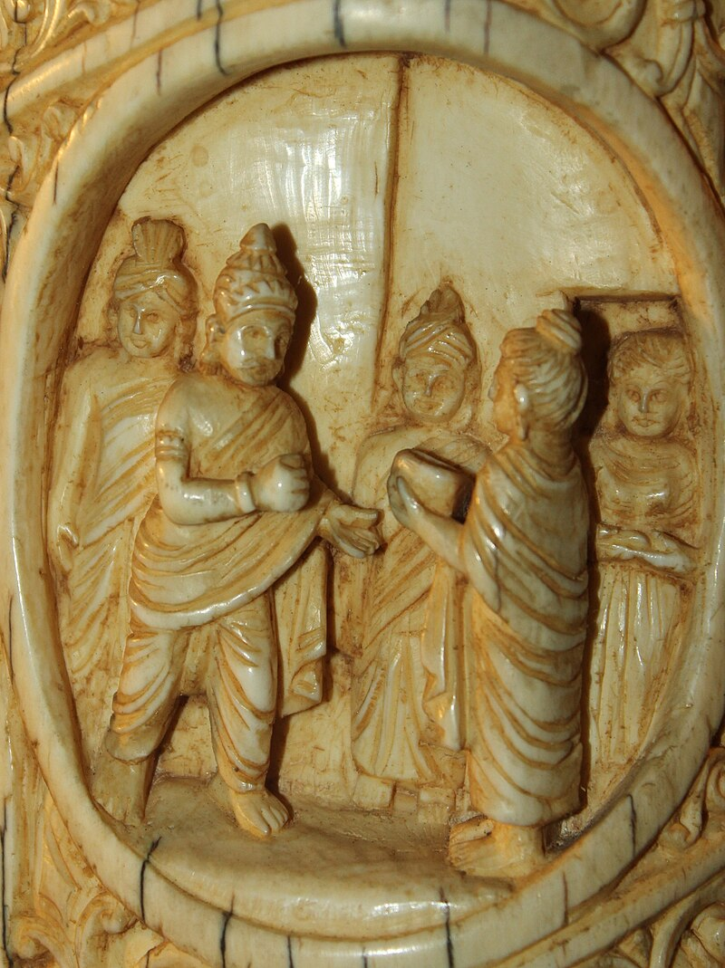

King Suddhodana meeting the Buddha in Kapilavattu

Source: [Author: Nomu420](https://commons.wikimedia.org/wiki/User:Nomu420)

Picture courtesy:

[User:Nomu420 - Wikimedia Commons](https://commons.wikimedia.org/wiki/User:Nomu420)

The Blessed One is said to have visited his father, King Suddhodana at his death-bed. [32]

The Buddha taught the Dhamma and the king became an Arahant. He enjoyed the bliss of liberation for seven days as a lay person before passing away [33].

**Helping Queen Mahāpajāpatī Gotamī**

The *Dakkhiṇāvibhaṅga Sutta* (MN 142) contains a passage in which Venerable Ānanda highlights the immense help the Blessed One provided to his foster mother, Mahāpajāpatī Gotamī, in her journey along the Dhamma path. He states:

*“…The Blessed One has been truly helpful to Mahāpajāpatī Gotamī. It is because of the Blessed One that she has gone for refuge to the Buddha, the Dhamma, and the Saṅgha and possesses unwavering confidence in them.”*

These four qualities—refuge in the Triple Gem and unwavering confidence—are the defining factors of stream-entry (*sotāpatti*). [34] Thus, from this account, it is evident that by this time, Mahāpajāpatī Gotamī had already attained the first stage of enlightenment.

According to the scriptures, she played a pivotal role in the establishment of the Bhikkhunī Saṅgha, paving the way for countless women to walk the path of renunciation. She later became a great teacher and ultimately attained Arahantship. [35]

In the *Therīgāthā*, she expressed her deep gratitude to the Buddha with these profound verses:

“Since I have seen the Blessed One,  
this bag of bones is my last.  
Transmigration through births is finished,  
now there’ll be no more future lives.

I see the disciples in harmony,  
resolute, always staunchly vigorous—  
this is my homage to the Buddhas!

It was truly for the benefit of many  
that Queen Māyā gave birth to Gotama.  
He swept away the mass of suffering  
for those stricken by sickness and death.” [36]

With unwavering faith and diligence, Mahāpajāpatī Gotamī fulfilled her spiritual journey,

exemplifying the highest gratitude by realizing the very liberation the Buddha so compassionately taught.

**Guiding His Mother to the Dhamma in the Deva Realm**

According to the scriptures and tradition, Queen Mahāmāyā, the mother of the Buddha, was reborn in the *Tusita* Deva Realm as a radiant celestial being known as *Santusita Deva*—also referred to as the "Mother Deva." Though she had departed from the human world just seven days after giving birth to Prince Siddhartha, her connection to him remained profound beyond lifetimes.

The Blessed One, out of boundless compassion, ascended to the deva world to share the Dhamma with his mother and the celestial beings. The texts describe this extraordinary event:

*“…When the Buddha went to the Tāvatimsa deva world, his mother, who had been reborn in the Tusita deva world as Santusita Deva, also descended to Tāvatimsa. There, throughout the three months of the vassa (rain retreat), the Blessed One expounded the Abhidhamma to the devas and brahmas. As a result, Santusita Deva attained the fruit of stream-entry (sotāpatti).”* [37]

Thus, even beyond the human realm, the Buddha fulfilled his sacred duty as a son—not only honouring his mother with gratitude but bestowing upon her the highest gift: the path to liberation.

Earlier, we saw a passage that speaks of the fate of mothers who give birth to future Buddhas:

“*That is so true, Ānanda! The mothers of being’s intent on awakening are short-lived. Seven days after giving birth to a being destined for enlightenment, they pass away and are reborn among the joyful gods of the Tusita heaven.” [38]*

This profound moment in history stands as a testament to the Buddha’s infinite compassion—a love that transcended the boundaries of life and death, ensuring that even his mother could walk the path toward the end of suffering.

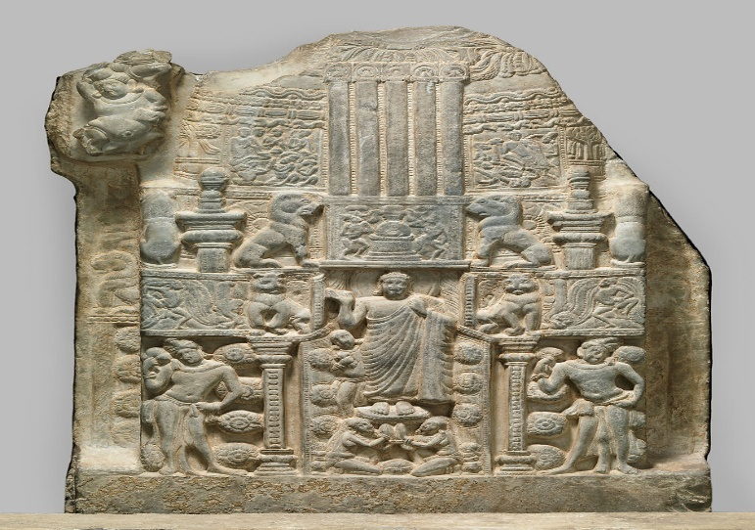

**The Blessed One coming from the Deva- loka** after teaching to his mother who was born as a young deva: Nagarjunakonda Stupa Site 6, Guntur district, Andhra Pradesh. Picture courtesy: https://www.metmuseum.org.

This Section provides an outline of life of Gotama Buddha as child and a young man living a luxurious worldly life. Brief descriptions are given of the Buddha’s immediate family, most of whom ordained under him. The information is from scriptures. To elaborate specific points/events and to fill some gaps, we have taken some information from traditional Buddhist books and other sources which are documented in the notes and references at the end.

In the next section (Section: 3), we will recount the story of Prince Siddhartha’s departure from the palace at the age of twenty-nine to embrace the life of an ascetic, followed by his attainment of Buddhahood at thirty-five.

**End Notes: Section 2**

1. Why he was called Siddhartha is described in detail in Chapter 1: Naming Ceremonies: The Great Chronicles of Buddhas by Venerable Mingun Sayadaw.
2. About his parents’ the Buddha said: “…my native place is Kapilavatthu, King Suddhodana is my father, my birth mother is Queen Maya…”, p, 264. This passage is translated from: Gotama Buddha Vamsa—Lineage of the Buddha Gotama: Buddha-Vamsa-Pali & Chariya Pitaka Pali: vol.38: Buddha Jayanti Publication.
3. In MN: Notes: 1291 give information about Queen Mahapajapati becoming the foster mother of the Buddha.
4. Ud.5.2 (Short lived sutta Translated by Bhikkhu Sujato), for details see: MN: 123 (Wonderful and marvellous sutta) & AN:4: 127 (Astounding sutta).
5. Thag: 10.1 (Kāludāyi).
6. The Buddha declared Mahāpajāpatī Gotamī as the foremost of bhikkhunī disciples in seniority: see: AN1:235 (Foremost). For more details of Maha Prajapati: see: AN8: 51 (Gothami sutta), Thig: 66 & <https://dahampada.github.io/> .
7. ThiAp: 7: (Maha Pajapati Gothami)
8. For detailed description of this event, see: Chapter 1: The story of Kaladevala the hermit: The Great Chronicles of Buddhas by Venerable Mingun Sayadaw.
9. Snp: 3.11 (Nālaka sutta: translated from Pali by Bhikkhu Sujato).
10. MN:36 (Mahāsaccaka Sutta). **Note:** The commentary (Majjima Nikaya Attakatha) says this:

    “…during the Bodhisatta’s boyhood as a prince, on one occasion his father led a ceremonial ploughing at a traditional festival of the Sakyans. The prince was brought to the festival and a place was prepared for him under a rose-apple tree. When his attendants left him to watch the ploughing ceremony, the prince, finding himself all alone, spontaneously sat up in the meditation posture and attained the first jhāna through mindfulness of breathing. When the attendants returned and found the boy seated in meditation, they reported this to the king, who came and bowed down in veneration to his son…’ **,** see:MN: Notes: 389, p.1101.
11. This passage is translated from: Gotama Buddha Vamsa—Lineage of the Buddha Gotama: Buddha-Vamsa-Pali & Chariya Pitaka Pali: vol.38: Buddha Jayanti Publication.

    This is mentioned in Buddhavamsa Pali- Chariya Pitaka: Linage of Buddha Gotama.
12. **See**: AN3:39.
13. For details see: Chapter 2: The accession to the throne: The Great Chronicles of Buddhas by Venerable Mingun Sayadaw.
14. AN1: 243. *Yasodharā Theri is also known as -Baddakacchana, Bimba and Rāhula mātha (mother of Rāhula). * Mp identifies her as Rāhulamātā, the mother of Rāhula; hence she was the Buddha’s wife, better known in Buddhist tradition by the name Yasodharā, see: AN: Notes: 126.
15. ThiAp:28 (Yasodharā: Translated by Jonathan S. Walters).
16. Ud:3.2 (Translated by Bhikkhu Sujato).
17. AN1:230* He was the Buddha’s half-brother, son of Suddhodana and Mahāpajāpati Gotamī. The story of how he left his fiancée to become a bhikkhu is told in Ud 3:2, 21–24. He is instructed by the Buddha at SN 21:8 and praised in AN at 8:9. His verses are at Th 157–58, see: AN: Note:111.
18. Thag:2.19 (Nanda: translated by Bhikkhu Sujato)
19. ThaAp:1.13 ( translated by Bhikkhu Sujato: )*Details regarding Nanda Thera see: <https://dahampada.github.io/>
20. AN1:240 * Also known as Sundarīnandā because of her beauty, she was the Buddha’s half-sister and the full sister of Nanda. Her story is in Nyanaponika and Hecker 2003: 282–85. She has verses at Thī 82–86, see: AN: Notes: 121.
21. Thig:2.19 (Translated by Bhikkhu Sujato).)
22. VP: Mahākhandhaka:41 Rahula’s story: (translated by Bhikkhu Brahmali).
23. For details see: VP: Mahākhandhaka:41.
24. MN :147 (Cūḷarāhulovāda Sutta)
25. MN: Notes: 1325, p. 1184: says that: those many thousands of deities who were present at this discourse became noble ones. For details regarding Rāhula Thera see: <https://dahampada.github.io/>
26. AN1:209 * The Buddha’s son. His first encounter with his father, when he was seven, is related at Vin I 82,8–31. The Buddha addresses the following discourses to him: MN 61, MN 62, MN 147; SN 18:1–22; SN 22:91–92; SN 35:121 (= MN 147); and Sn 2:11, **See:** AN: Note:92.
27. Thag: 4. ( Rāhula Translated by Bhikkhu Sujato).
28. ThaAp:16 (Rāhula Translated by Jonathan S. Walters).
29. AN2: 33.
30. For details see: Chapter:17: King Suddhodana attaining the first path & 3rd path: The Great Chronicles of Buddhas by Venerable Mingun Sayadaw.
31. Ibid.
32. About King Suddhodhana becoming an arahant: In Thī-a 3, [the commentator] Dhammapāla says, ‘He had the young Nanda and the young Rāhula go forth and then the Teacher returned again to Rājagaha. On a later occasion, when the Teacher was living in the Kūṭāgāra Hall near Vesālī, the great King Suddhodana attained final quenching [nibbāna], having realized arahantship even while he was still [reigning] under the white parasol. The inclination to go forth arose in Mahā-Pajāpatī’ (Pruitt 1998: 6–7). This is also given at Thī-a 141 (Pruitt 1998: 181). King Suddhodana is the only layman I know of who became an arahant and remained a layman, which means he could not have lived more than seven days after becoming an arahant”, see: AN: Notes: 1731.
33. Chapter:17: King Suddhodana attaining the first path & 3rd path: The Great Chronicles of Buddhas by Venerable Mingun Sayadaw.
34. MN: Note: 1293.
35. AN:8: 51. It says that she ordained with 500 Sakyan ladies.
36. Thig:6.6 (Translated by Bhikkhu Sujato).
37. Dhp: 14.2 . * The story of the Buddha’s return from the Tāvatimsa Deva world, see: Illustrated Dhammapada: Ven.Weragoda Sarada Maha Thero.
38. KN:Ud:5.2 (Short lived sutta).